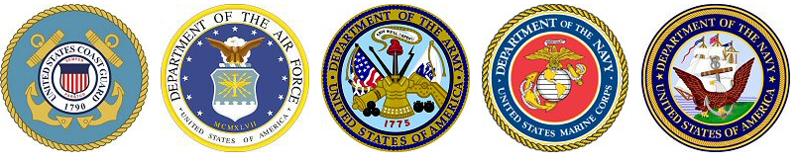

Military Visitation Schedule

~~ During Lunches in the center Cafeteria from 11:17 am – 1:32 pm ~~

**AIR FORCE**

**1st Thursday of the month | SSG Kyle Solberg**

[**kyle.solberg@us.af.mil**](mailto:kyle.solberg@us.af.mil) **phone: 402-547-1742**

**ARMY**

**2nd Wednesday of the month | SSG Kevin Guinto**

[**kevin.m.guinto.mil@army.mil**](mailto:kevin.m.guinto.mil@army.mil) **phone: 402-691-4578**

**MARINES**

**3rd Monday of the month | SGT Ben Saida Youssef**

[**Youssef.Bensaida@marines.usmc.mil**](mailto:Youssef.Bensaida@marines.usmc.mil) **phone: 515-314-4559**

**Navy**

**3rd Thursday of the month | CS2 (SW) Daniel Grabenschroer**

[**daniel.s.grabenschro@navy.mil**](mailto:daniel.s.grabenschro@navy.mil) **phone: 402-575-0549**

**Nebraska Army National Guard**

**2nd Thursday of the month | SGT Megan Liekhus**

[**megan.m.liekhus.mil@army.mil**](mailto:megan.m.liekhus.mil@army.mil) **phone: 402-720-1191**

Military Service Academies

Lt. Col. Patrick Ryan, United States Air Force Academy | CDR Eric Taylor, United States Naval Academy

[patrick.ryan@ops.org](mailto:patrick.ryan@ops.org) phone: 402-990-1890 | **etaylor@1994.usna.com** phone:858-729-8348